**Plugging into the Future: An Exploration of Electricity Consumption Patterns**

**Define Problem / Problem Understanding**

India is the world's third-largest producer and third-largest consumer of electricity. The national electric grid in India has an installed capacity of 370.106 GW as of 31 March 2020. Renewable power plants, which also include large hydroelectric plants, constitute 35.86% of India's total installed capacity. During the fiscal year (FY) 2019–20, the total electricity generation in the country was 1,598 TWh, of which 1,383.5 TWh generated by utilities. The gross electricity consumption per capita in FY2019 was 1,208 kWh. In 2015-16, electric energy consumption in agriculture was recorded as being the highest (17.89%) worldwide. The per capita electricity consumption is low compared to most other countries despite India having a low electricity tariff. In light of the recent COVID-19 situation, when everyone has been under lockdown for the months of March to June the impacts of the lockdown on economic activities have been faced by every sector in a positive or a negative way. The dataset is exhaustive in its demonstration of energy consumption state wise. Analysing Electricity Consumption in India from Jan 2019 till 5 th December 2020. This dataset contains a record of Electricity consumption in each states of India, here we are going to analyse State wise , Region wise and Overall Electricity consumption in India.

**Business requirements**

The business requirements for analyzing analysis on electricity consumption in IndiaIdentify the current patterns of electricity consumption in different regions and sectors of India. This information can be used to identify areas where consumption is high and areas where it is low. Identify opportunities for improving energy efficiency and reducing consumption in different sectors and regions. This information can be used to develop policies and programs to promote energy efficiency. This information can be used by government agencies, electricity providers, and investors to develop policies and make investment decisions that promote sustainable energy development and consumption in India.

**Social or Business Impact.**

**Social Impact**: By providing access to electricity, the analysis can help to improve the quality of life for people living in areas without access to electricity, including providing access to lighting, heating, and cooling, and powering essential services such as hospitals and schools..

**Business** **Model/Impact**: By understanding consumption patterns and trends, the analysis can help businesses identify market opportunities and develop strategies to meet the growing demand for electricity in India.

**Data Collection**

Data collection is the process of gathering and measuring information on variables of interest, in an established systematic fashion that enables one to answer stated research questions, test hypotheses, and evaluate outcomes and generate insights from the data.

**Understand the data**

In Dataset Consumption.csv data is in the form of a time series for a period of 24 months beginning from 2nd Jan 2019 till 5 th December 2020. Columns contains States, Regions, Latitude, Longitude, Dates andUsage. The dataset has been scraped from the weekly energy reports of POSOC. Fields Include States - Indian States Regions- States in Regions on Indian Map Latitude - States in Regions on Indian Map Longitude - Geographical Coordinates of States Dates - Dates of Usage Usage - Power consumed in Mega Units(MU)

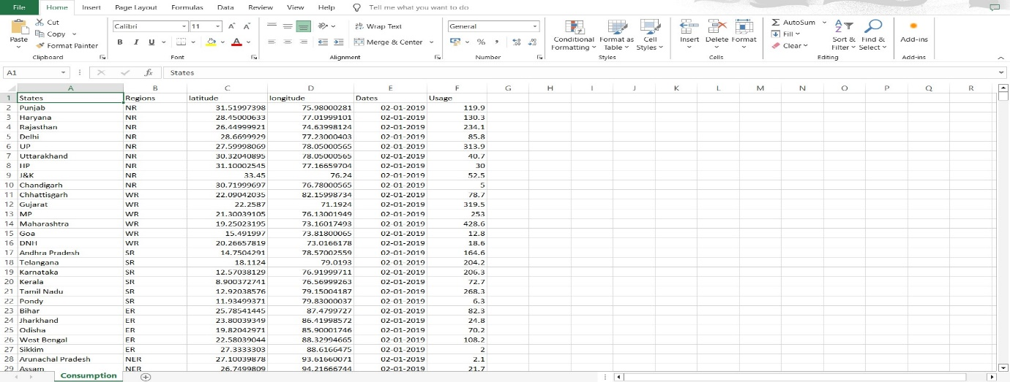

**Data Preparation**

Preparing the data for visualization involves cleaning the data to remove irrelevant or missing data, transforming the data into a format that can be easily visualized, exploring the data to identify patterns and trends, filtering the data to focus on specific subsets of data, preparing the data for visualization software, and ensuring the data is accurate and complete. This process helps to make the data easily understandable and ready for creating visualizations to gain insights into the performance and efficiency.

**Data Visualization**

Data visualization is the process of creating graphical representations of data in order to help people understand and explore the information. The goal of data visualization is to make complex data sets more accessible, intuitive, and easier to interpret. By using visual elements such as charts, graphs, and maps, data visualizations can help people quickly identify patterns, trends, and outliers in the data.

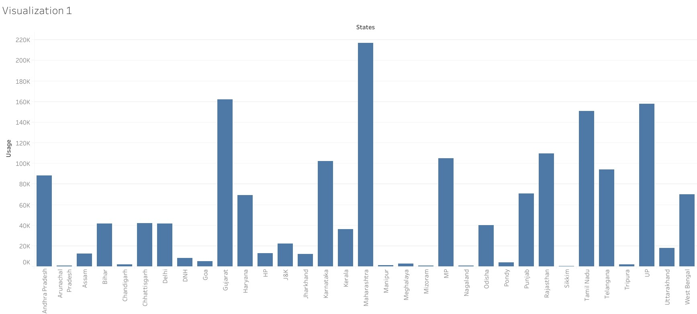

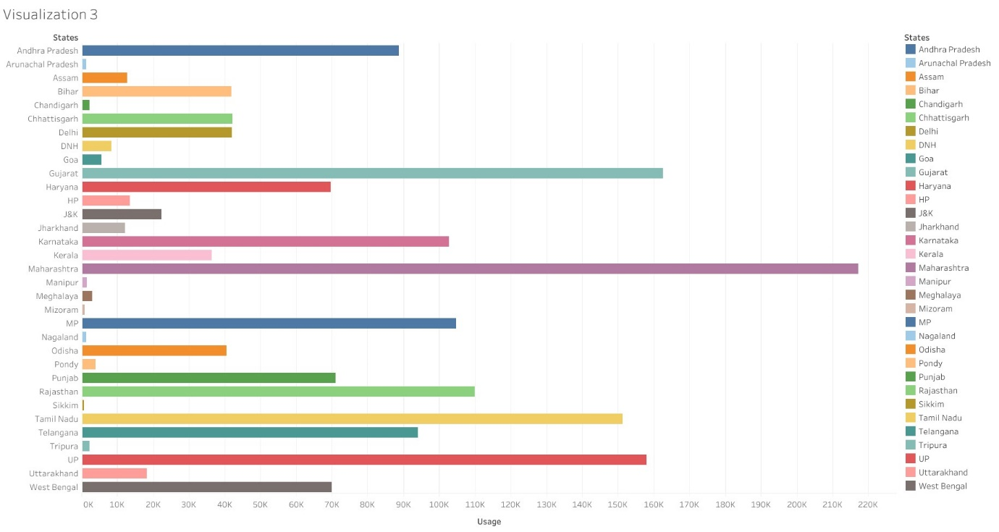

**Dashboard**

A dashboard is a graphical user interface (GUI) that displays information and data in an organized, easy-to-read format. Dashboards are often used to provide real-time monitoring and analysis of data, and are typically designed for a specific purpose or use case. Dashboards can be used in a variety of settings, such as business, finance, manufacturing, healthcare, and many other industries. They can be used to track key performance indicators (KPIs), monitor performance metrics, and display data in the form of charts, graphs, and tables.

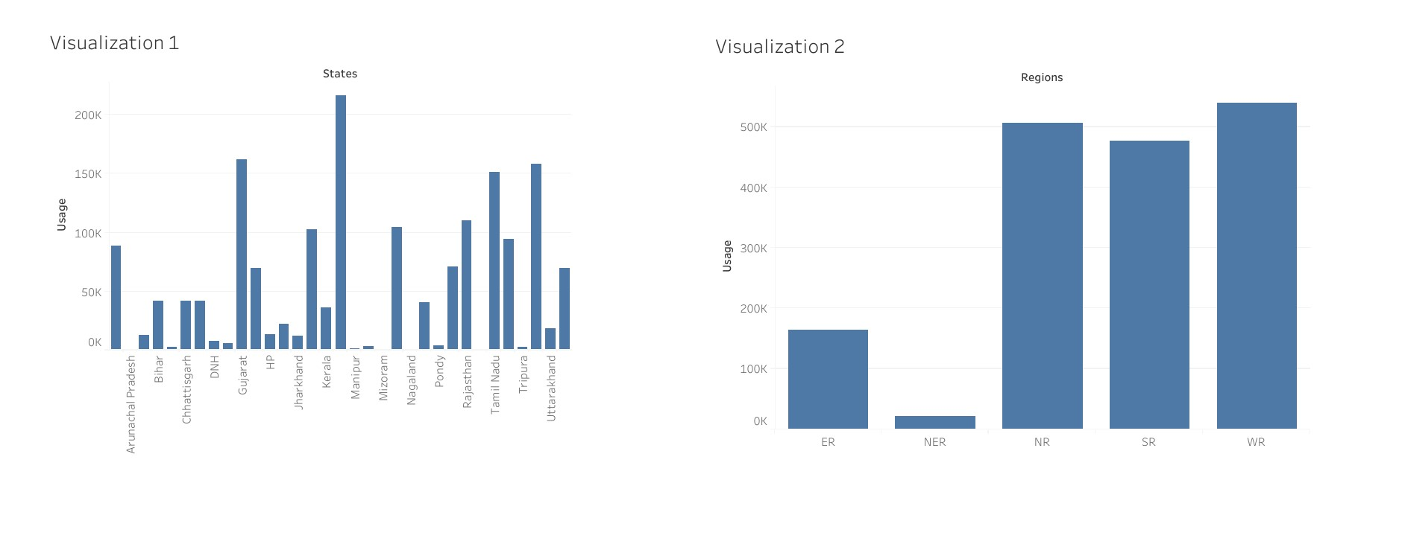

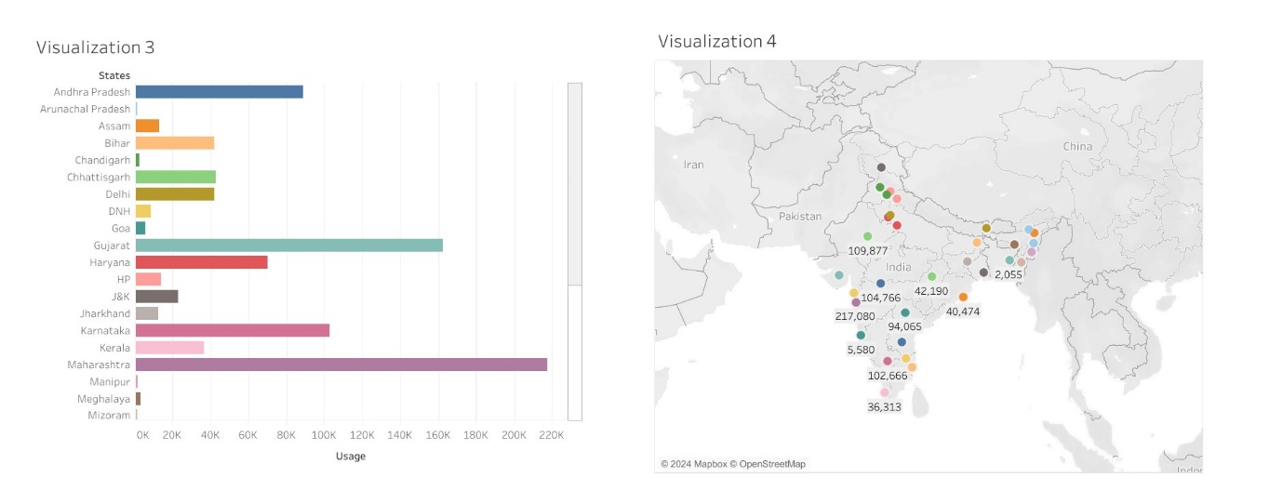

**Story**

A data story is a way of presenting data and analysis in a narrative format, with the goal of making the information more engaging and easier to understand. A data story typically includes a clear introduction that sets the stage and explains the context for the data, a body that presents the data and analysis in a logical and systematic way, and a conclusion that summarizes the key findings and highlights their implications. Data stories can be told using a variety of mediums, such as reports, presentations, interactive visualizations, and videos.

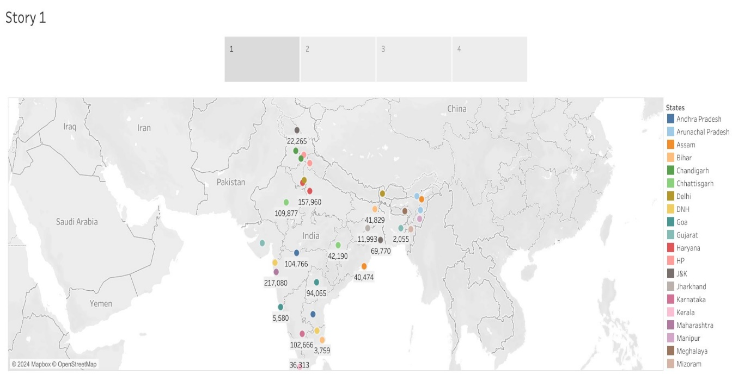

**Web integration**

Publishing helps us to track and monitor key performance metrics, to communicate results and progress. help a publisher stay informed, make better decisions, and communicate their performance to others.

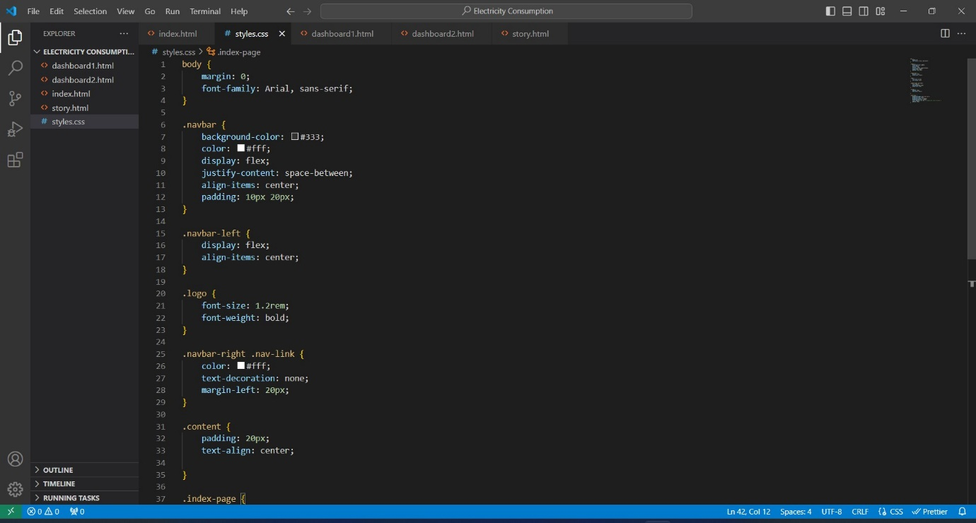

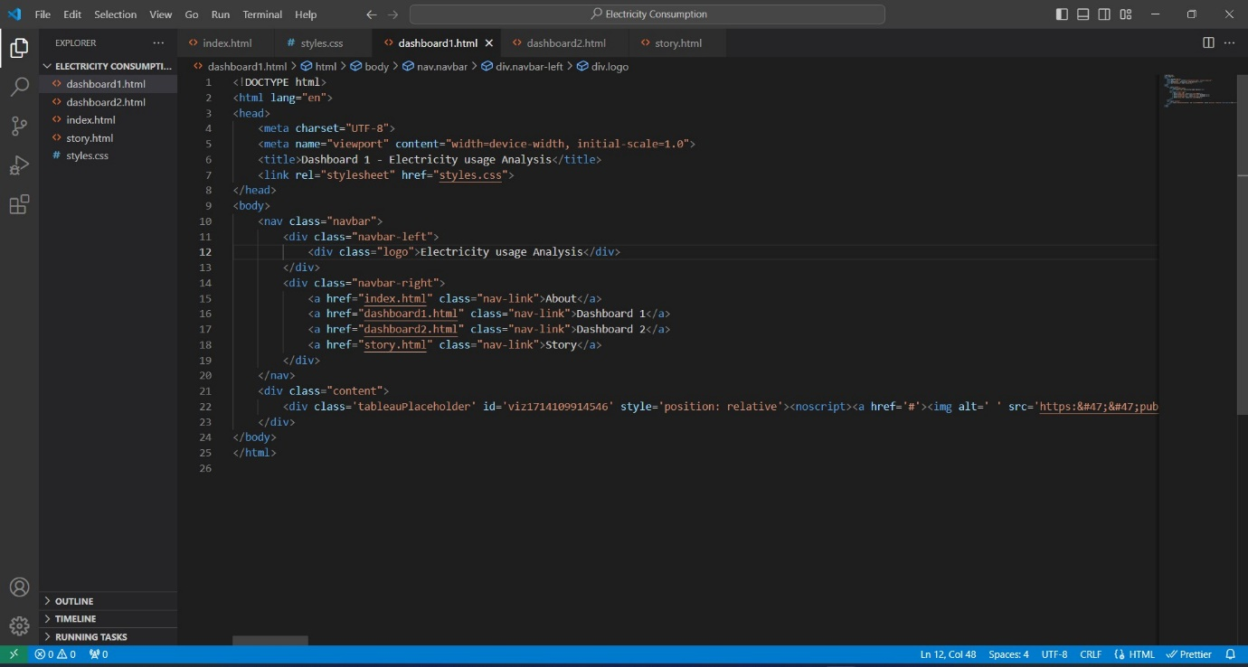

**BY:**

**Jagarapu Guna Vishnu Vamsi**

**21A35A0315**

**PRAGATI ENGINEERING COLLEGE**